&
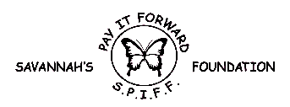
“FEED THE NEED” GOLF OUTING
SATURDAY, JUNE 22nd, 2019
At
Ives Grove Golf Course
14101 Washington Ave
Sturtevant, WI 53177

SPONSORSHIP OPPORTUNITIES

HOLE SIGN OR CART SIGN SPONSOR

Your Company’s Name Will Be Prominently Displayed on Signage Throughout this Worthwhile Fund Raising Event!

____ Yes, I would Like to Sponsor ___ Holes @ $100 ea.

____ Yes, I would Like to Sponsor ___ Carts @ $50 ea

Tax id 27-0969338

DOOR PRIZE SPONSOR

____ Yes, I Would Like To Contribute a Prize
_____ Please Pick Up Our Donation

Name: _________________________________________

Address: ________________________________________

Contact Number: _________________________________

Please attach a business card with your company’s logo if available.

PLEASE MAKE CHECKS PAYABLE TO S.P.I.F.F. AND RETURN FORM WITH PAYMENT OR DONATION TO: Chuck or Connie Kirchner—8739 Cloverleaf Drive Mt Pleasant, WI 53406 PHONE: 262-939-7237

